Brian Morman
Creative Thinking EMBA 60
“Make sure to plan for six months of delay if you want to buy anything”. This was the first statement that surprised me about electronics procurement at the Boeing Company. I’m new here at Boeing, I’ve only been with the company 7 months at this time, but I have ten years in the electronics industry under my belt. So, when our sourcing team told me to count on six months for procurement, I drew on my experience. Sure, in the post Covid marketplace things were backordered, fast delivery cost extra, and suppliers are quoting long lead times I thought. So, I adjusted my schedule from 20 weeks to 26 weeks from completed bill of materials to receipt of items. “No”, she said, “six months extra”. Just like that, my expected project completion date was extended nearly a year with procurement taking 46 weeks. This is where I found the problem I am pursing, prototype part procurement at Boeing takes entirely too long which generates waste, creates obsolescence risk and forces key design decision to be made earlier and with less data. The problem I hope to resolve is how can Boeing procure custom assemblies faster to make prototype builds happen faster. For each section of this paper, I have tried to summarize the ideas generated and highlight some of my favorite ideas or most valuable learnings in yellow. A full appendix at the end explains each in more detail and shows the list of generated ideas.
1. Associating—
Association is one of the driving forces behind my desire to pursue a solution to this problem statement. For the last ten years, I had worked for GE Appliances in electronics design. We purchased many similar parts to what are used in my new role at Boeing. We used many of the same suppliers. There are definite differences between procuring parts for a dishwasher and some of America’s most powerful war fighters, but I couldn’t believe how different our processes and procedures were. Since I hold some expertise in this analogous domain, I decided I may be able to offer a unique solution to this problem. From that jumping off point, I began to broaden my horizons to other more distinct domains that are more abstractly related. I have included my full list of associations in Appendix A but here are some of my favorite ideas to highlight them.
Culinary Arts -
Similarity: Balancing quality, cost and availability to create a product
Best Practice Learning: Chef’s foster long term relationships with their product suppliers to get the highest quality portion of a product offering.
Film Production and Set Design -
Similarity: Set designers use a scaled prototyping approach to test a concept before the final build. This is very similar to the engineering prototyping process.
Best Practice Learning: Set designers tend to make many of their prototypes by hand at scale and using available materials to test fast.
Like chefs competing for the highest quality ingredients, what benefits might we get from forging strategic partnerships with individual suppliers rather than always looking for the best cost. Economies of scale, preferred customer status for distribution parts, shorter lead times? And like film designers what if we focused a little less on exactly representative prototypes and more on getting into testing quickly. How could our products better leverage scale models to learn fast? Could we run testing on lower performance mission computers with more aggressive test inputs and predict the outcomes of higher performance machines? Lower performance parts are often easier and cheaper to obtain.
2. Observing—
Observing the full purchasing process in action was not an option. The assignment due date would come well before I could complete a full procurement cycle, so I did the next best thing and interviewed several people who have worked through this process at various stages every day in their roles. I met with a supplier requirements engineer who handles a great deal of supplier management, a procurement agent who buys parts an engineering manager who feels frustration with how long this process takes, and ultimately, I was connected to a manager of lean initiatives. This is where I discovered that the lean team had done me a huge favor in my project. Over the last year, several lean practitioners have spent many hours putting together a workflow map of how this process typically runs. (See appendix B for full 6-page workflow). By listening to the key participants and looking at the workflow map, I was able to better home in on some specific places that our procurement process is hitting bumps in the road. Here are some of the key takeaways I found from my observation and interviewing:
Interview take aways: Buyer’s rarely have expertise in the technology they are buying. In many cases they feel totally uncomfortable answering questions from their suppliers about what is needed. Engineers rarely understand the buying process. They don’t know who they can buy from and why or why not they are approved vendors. Quality is looped in once negotiation is complete and are even more out of the loop about what is being built by the time things are ready to order. This lack of fundamental understanding results in a long chain of communication that moves slowly.
Process map: From reviewing the process map, I found several tasks that are happening serially that should and could be happening in parallel. For instance, the scheduling group holds a BOM review to determine how parts delivery will impact project schedule before the TDP is sent to suppliers for design feedback. Both these processes can force design changes and restart the workflow. In this case I believe finding problems early saves wasted work. Both tasks should be kicked off at once.
Think like an anthropologist: After reviewing the full design flow I tried to take an anthropologist’s eye to the steps laid out to see where other hidden problems may lie. I noticed first that there are many steps to this flow. Many of those steps are small, or quick, or even automated. My gut instinct was to overlook those and go to the longer tasks, but I think these small steps are a significant problem to our flow weather or not the timeline shows them as one. A team of engineers agreed that a task such as an approval would take a few hours to view an email and click ok. Then I thought of my inbox. There will never be a day in which all the required approvers see the request within hours or even within a day and click ok. Each approval step and approver are a potential bottleneck. Good communication of what is being procured is needed but physical approval tasks need to be minimized to allow for the real work to be done.
3. Questioning—
I used the reverse assumption technique to question my assumptions about what I know about the procurement process. From that list I generated a short list of ideas that pose new ways to address our procurement problems. I tried to move quickly through my options to generate more base ideas and then came back to add some more thoughts about the how or why to each base idea. The full list of ideas generated from the questioning technique are in Appendix C but highlighted below are some of my favorite ideas from this process of questioning assumptions.
Many approvals needed and will take a long time – Few approvals will be needed. – What If one person has approval authority on the spend or approval to bypass a vote?
Multiple vendors will be approached – One vendor is chosen as a strategic partner. In my experience, we typically know which vendor we want to build a part. We know their expertise, we know who executes well, and for a particularly familiar supplier we tend to even know who might quote the best price. What if we could characterize which vendor should make a final product in the early development stage? We could control the design to hit their strong points and hopefully create a cost advantage that could offset some loss in negotiation power.
Prices will be negotiated based on the BOM – Prices are negotiated before the BOM. What if we negotiate the cost of individual parts, or the cost of an assembly that meets a certain set of requirements, then created purchase agreements for a blanket of items. Could we get close to a final cost before the design is totally compete?
4. Networking— While I knew it would be awkward, I looked forward to this step in the process for a reason to reach out to some friends from my old roles, to catch up and as an invitation for them to reach out to me as well should they ever have a need in their future roles. For this step I reached out via phone call to two friends who have experience in procurement who could offer unique perspectives on purchasing.
First, I called Carson Fields. Carson is another friend from GE who has also gone on to work at new places. At GEA he was a supplier management engineer for electronics before taking a procurement manager’s position at an international food brand. Carson and I spent a long time talking about his time at GE. While he was in his electronics role, his team worked to tackle the same problem I am. I managed to take away a few ideas from our conversation that I am excited to share with my team at Boeing. Each idea is described here in one sentence, but my full notes are included in Appendix D.
- The iBOUGHTA system – Carson described a system that took engineering inputs about systems we had bought that create outputs for procurement agents to develop supplier relationships outside the quoting process.
- Strategic partnerships and alternate components – Carson emphasized strategic supplier relationships for their value when the buying market is strained.
- Global AVL – Carson highlighted a system of up front alternate selection so procurement agents didn’t have to waste time looking for backups if they can’t purchase the ideal part.
I next reached out to Reid Fuente, who worked many supply chain roles with me at GEA but more recently worked as a manufacturing engineer at an automotive startup in Arizona. I took notes from our conversation and after much time catching upon our personal lives I explained the challenge to Reid. Here are the takeaways I got from our conversation:
Procurement teams and project teams here are much smaller. One individual knows what is needed, research places to buy that item, negotiates with the source, and writes the PO to make it happen. The individuals buying have a full understanding of the budget, so they are careful with the money spent. There are no formal approval processes to spend, and each project manager is given the freedom to spend what they have how they see fit. I noticed from Reid’s description that at an automotive startup, purchasing doesn’t happen very fast either but not because of miscommunications or slow systems processing. There is more time spent discussing a purchase considering the full business’s needs. All team members are read in on the goal and are pushing in the same direction understanding they may not always have the funds they need to do what they think is best. They must think more agilely about how to a get what they need and use it effectively.
5. Experimenting— This project timed up quite beneficially with a project I am leading at work for internal research and design efforts. Since the project is IRAD funded, it funds no flight worthy materials and isn’t subject to nearly as many regulatory steps as more standard procurement might. Experimenting in the IRAD space is exactly the right way to launch new ideas at Boeing. My team has taken on several of the ideas from this project in support of that IRAD effort already. When observing, I found each approval is a potential bottle neck. From questioning: what if no approvals were needed? So, we followed these questions to an idea, for our IRAD project we will not use a webhosted request and approval system. Our team meets weekly to review a spreadsheet and agree as a team to purchase or not with one verbal meeting vote. From Association I saw how set designers build scale models from available materials. Our team is discussing building a scale model of this product knowing it won’t meet all the design requirements using items we have on hand or have procured in the past to shorten the supply chain.
6. Teaming— Connections I made while researching this process helped me to put together a team of steak holders who care about solving our procurement problem. The lean team that created the process map is particularly enthused about the list of ideas I have been able to generate. The next steps will be to present these ideas to the lean team of steak holders that put this value stream map together and share the process I went through to create the list of ideas with the true experts on this subject to see what their minds can do with this process and hours of funding to pursue long term solutions to this challenge.
7. Pitching— Pitching these ideas will come after the Thanksgiving Holiday break which means I still have some time to refine my final pitch but in early to mid-December, I will present to the director of lean initiatives what ideas I have been able to generate through this effort. With limited time to present and a new relationship with this director, I am finding it somewhat difficult to decide which ideas to pitch. I think back to class and the bell curve of ideas. Most will be mediocre; some will be great, and some will be truly terrible. More importantly perhaps, I remember individuals are particularly bad at identifying the best ideas. With these two thoughts in mind here are the ideas I plan to pitch, in what order, and why.
Idea Pitch 1) Consolidate approvals into one meeting vote. Webhosted approval processes always create bottlenecks for a process. Get the approvers together in a room once a week to discuss any requests and get them processed. – This I will pitch first. In my mind this is a non-radical idea that can easily create report and get buy in to try bigger steps. I would weigh this as a middle of the bell curve idea. It is somewhat obvious and will not fix the full problem, but it can help generate buy in for the bigger ideas.
Idea Pitch 2) Give project teams some IRAD funds and let program managers control them – Sometimes things are needed truly ASAP. Program managers sometimes need something right away. Enable them to get what they need to succeed. In this way we can take a step towards some of the ideas about ordering parts when we don’t yet know for sure what is needed. This could include promising funds to a supplier to hold parts without the exact part number identified. – This idea will come second. This includes some things Boeing is currently not comfortable with. Moving control of funds from one person to another will require a lot of approval but it is not unfamiliar. I think this idea moves farther from the center of the bell curve of idea quality and takes more work that idea one to implement.
Idea Pitch 3) Implement a Boeing version of iBOUGHTA to plan for the future of procurement. This system is an idea from an adjacent domain that could be implemented to the Boeing system to address several of the key problems I observed in our system today and fill knowledge gaps that create procurement delays today. – This idea will be pitched third. Creating a system like this would take Boeing several years and cost a great deal to implement. It also has the least obvious return on investment. I believe this idea could fix some fundamental problems in the buying loop and demystify the process for those involved to remove roadblocks. This is the idea that I believe resides furthest from the center of the bell curve.

Appendix A: Associating -full list of ideas
Event planning –
Similarity: Coordinating the timely execution of multiple tasks for one successful outcome
Best Practice Learning: Event planners keep a list of their preferred vendors to bring to the customer and in this way help the customer make decisions on what is needed quickly by providing a menu of options when a customer doesn’t know yet what they need.
Fashion Design -
Similarity: Constantly changing customer and supply chain
Best Practice Learning: An experiment in predicting customer wants
Content Creation and publication -
Similarity: Curating high quality products with many options to create a final product
Best Practice Learning: My preferred publications focus on high editorial standards for a quality product with a focus on the customer’s satisfaction.
Culinary Arts -
Similarity: Balancing quality, cost and availability to create a product
Best Practice Learning: Chef’s foster long term relationships with their product suppliers to get the highest quality portion of a product offering.
Urban Planning –
Similarity: Foresight and planning are needed to create something that other will build on with requirements that won’t be known for some time.
Best Practice Learning: Urban planners do a high degree of contingency planning for what may be needed given different population change scenarios and make decisions that have impact for many years to come.
Film Production and Set Design -
Similarity: Set designers use a scaled prototyping approach to test a concept before the final build. This is very similar to the engineering prototyping process.
Best Practice Learning: Set designers tend to make many of their prototypes by hand at scale and using available materials to test fast.
Software Development -
Similarity: An iterative process with changing requirements
Best Practice Learning: The agile approach to software involves shipping individually completed components of a product rather than a complete finished product.

Appendix B: Lean Team Procurement Workflow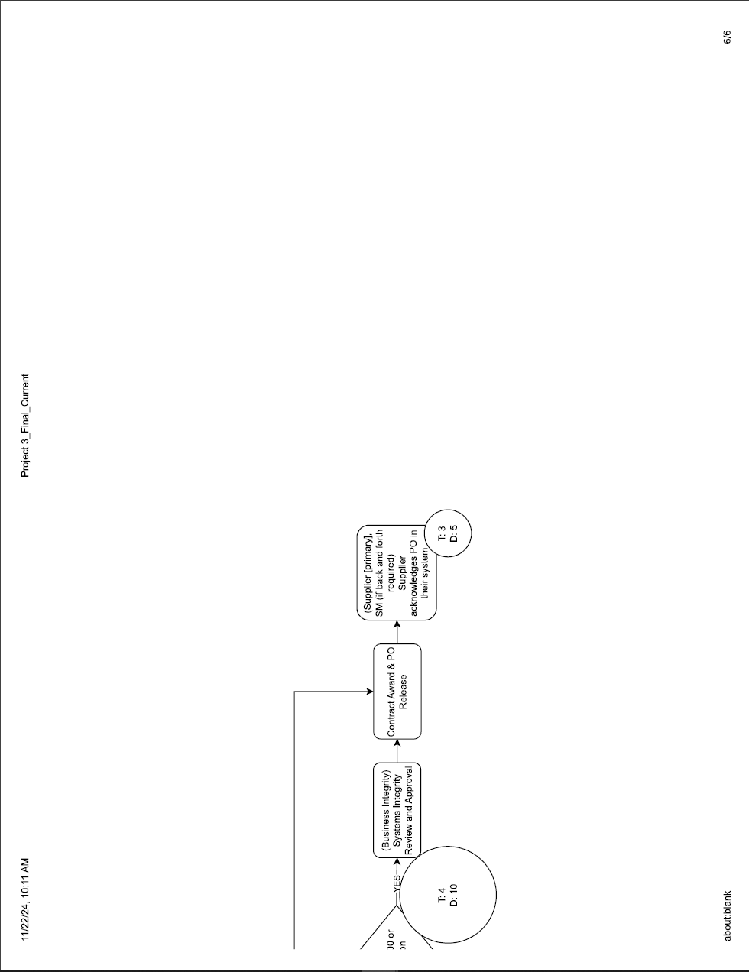 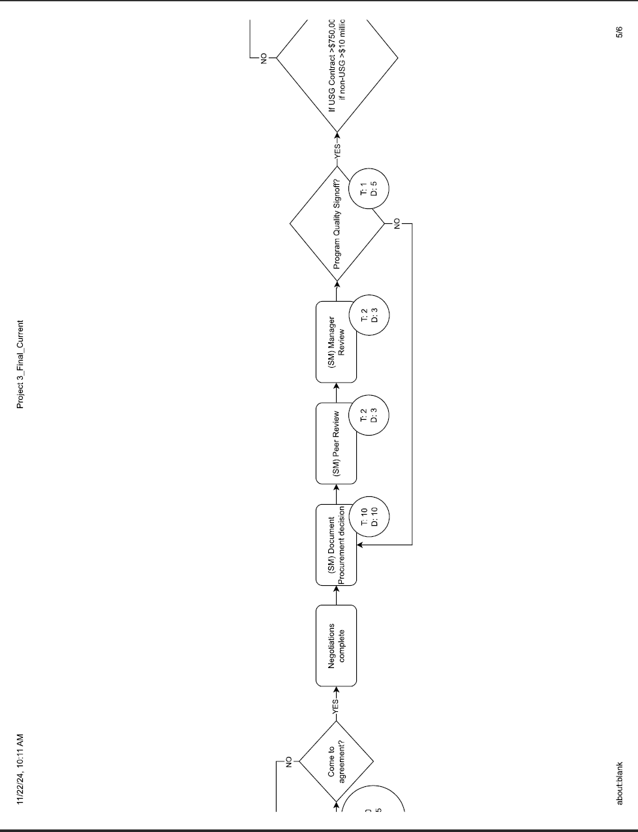 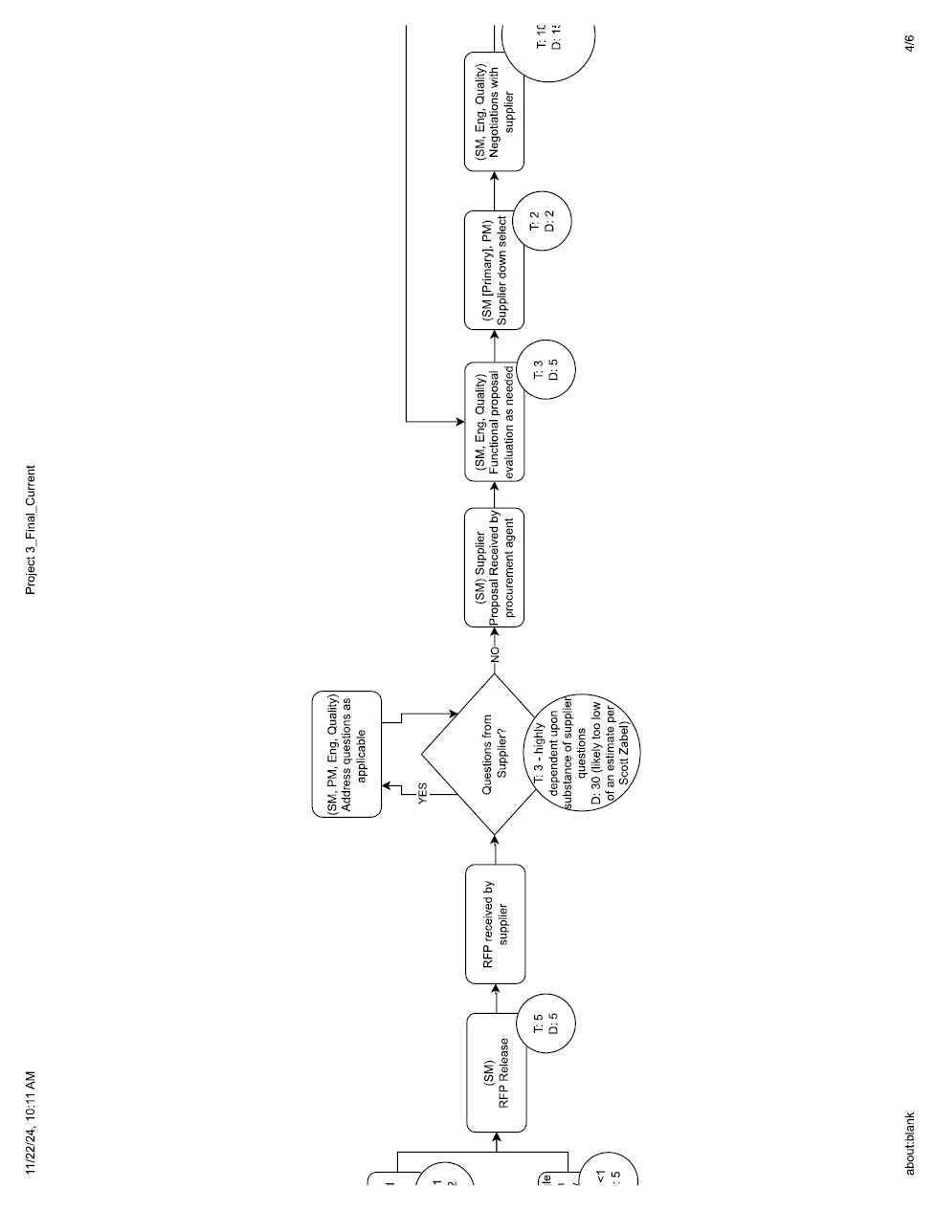 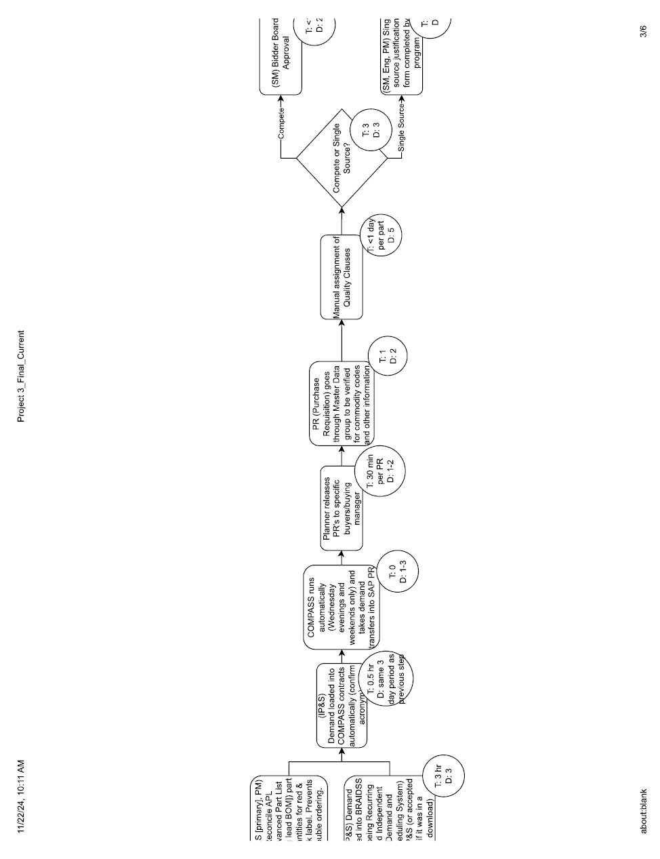 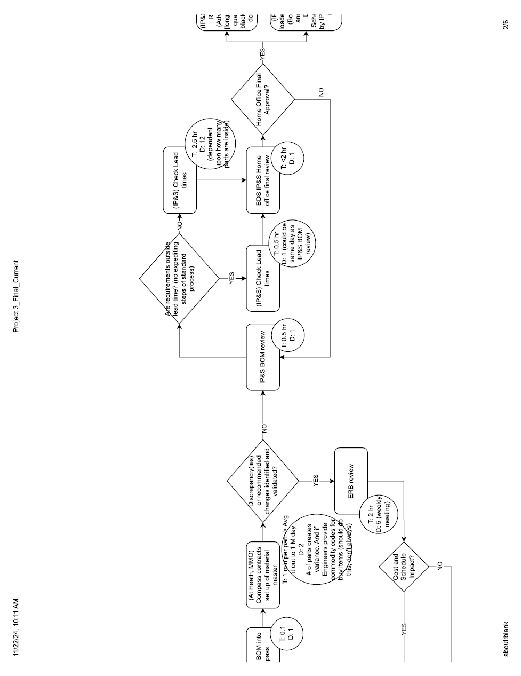 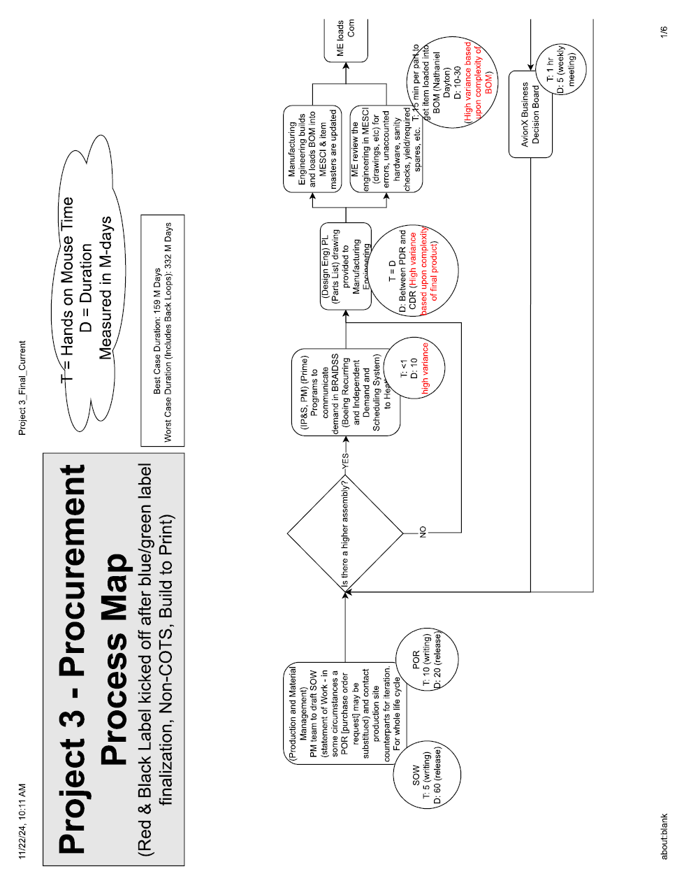

Appendix C Questioning full list of assumptions
Engineers determine what is needed – what if the sourcing team decided what to buy? What if sourcing were to try to estimate what parts will be needed at the start of each year? Could we buy a lump sum purchase of parts we are likely to use and not risk too much cash?
Use companies chosen by sourcing to procure – Engineer’s choose the vendors. What if engineering chose the vendors to quote and picked their procurement source. (I think this is a terrible idea but I’m trying to flex the muscle to not judge the idea).
Purchase requests come from a complete bill of materials – purchases are made before the BOM is complete – what if risk funding could be used to purchase items before a complete release package. Possibly certain key items could be identified for a high-risk purchase before review.
Finance and PM control the budget – Engineering or sourcing owns their own spend? - This could mean one less approval for any sign offs. Possibly sourcing or engineering could be accountable directly for costs during the program.
A statement of work will be written – Supplier proposes how they will do the work themselves. – Maybe a supplier could create their own build plan based on a set of drawings, and they propose the build plan and timing.
Many approvals needed and will take a long time – Few approvals will be needed. – What If one person has approval authority on the spend or approval to bypass a vote?
Multiple vendors will be approached – One vendor is chosen as a strategic partner. In my experience, we typically know which vendor we want to build a part. We know their expertise, we know who executes well, and for a particularly familiar supplier we tend to even know who might quote the best price. What if we could characterize which vendor should make a final product in the early development stage? We could control the design to hit their strong points and hopefully create a cost advantage that could offset some loss in negotiation power.
Prices will be negotiated based on the BOM – Prices are negotiated before the BOM. What if we negotiate the cost of individual parts, or the cost of an assembly that meets a certain set of requirements, then created purchase agreements for a blanket of items. Could we get close to a final cost before the design is totally compete?

Appendix D: Networking full notes
- The iBOUGHTA system – Carson described the biggest outcome of the project at GE which was a system the team called iBOUGHTA. IBOUGHTA is a system that executes at the time of an official drawing release. When a drawing release is submitted, the iBOUGHTA system asks an engineer to answer around 20 questions about their design. Those questions help to characterize any purchased assembly and group them into buckets based on those classifications. The iBOUGHTA team first spent several months training this system with data about past purchases then set it out for use in the engineering group. The system was able to take that input and generate several valuable outputs. In the short term this data paired with purchasing contract data shows engineers a quick and easy estimated cost value for a design before quoting. In the long run it can do much more. This system could allow for supplier selection to be done before final product release by giving an estimate of how a supplier may quote. A more out their potential is that this system could be used to let the purchasing team get insights into what engineering may ask for next by utilizing trends. By utilizing this database and good data engineering the procurement process was already changing dramatically when Carson and I left GE.
- Strategic partnerships and alternate components – Carson worked in electronics procurement during Covid which meant we experienced together historic supply chain issues. The takeaway here was that price, quality, and reliability have more nuance than before. It was important during supplier selection to choose suppliers strategically who share the power equally in the buy/sell relationship.
- Global AVL – Global AVL was utilized to put more information in the hands of the procurement agent. For any purchased component, global availability needs were added to the component library. This meant that when an engineer requested the use of a new part through the CAD library, they were also asked to find alternates as backups for that part this step could be waived for a time or delayed but would eventually need to be filled in. By doing this step early on, procurement agents were better equipped to handle part shortages and end of life issues that tended to be slow and time consuming to resolve for all involved.

